**CONTENT**

|  |  |  |
| --- | --- | --- |
| **S.No.** | **CONTENT** | **PAGE No.** |
| 1. | Abstract | 2 |
| 2. | Project Overview | 3 |
| 3. | System Design | 4 |
| 4. | Input Design | 8 |
| 5. | Output Design | 8 |
| 6. | Menu Level Description | 9 |
| 7. | Process Specification | 10 |
| 8. | Screen Layouts | 11 |
| 9. | Conclusion | 13 |
| 10. | Bibliography | 14 |

**ABSTRACT**

# The Pharmacy Management Software is an advanced web-based solution aimed at revolutionizing the way pharmacies manage their medication inventory. This system is designed to automate and streamline the process of tracking and updating medicine stocks in pharmacies, providing an easy-to-use interface for both pharmacy staff and administrators.

# With key features such as inventory management, medicine upload and deletion, and detailed tracking of expiration dates, the system ensures that pharmacies operate more efficiently and accurately.

# The software includes intuitive features for uploading and managing medicines, which helps eliminate the need for cumbersome paper records. The platform validates data entry to reduce human error, ensuring that all fields are filled in correctly and that the stock is always up-to-date.

# The system also tracks expiry dates, which ensures that outdated medicines are flagged, preventing any adverse effects from selling expired products.

# Built using modern web technologies, the Pharmacy Management Software is scalable, responsive, and cross-platform compatible. This allows pharmacies to access the system from various devices, enabling pharmacy staff to manage their inventory efficiently from any location.

# Furthermore, the software is designed to be flexible, allowing for future enhancements such as integration with third-party suppliers, automation of purchase orders, and sales tracking.

# The implementation of this system leads to a more organized, efficient, and streamlined process for managing medicines, thereby improving operational efficiency, reducing manual labor, and ensuring compliance with regulations. It is ideal for pharmacies of all sizes looking to modernize their inventory management and improve service delivery to customers.

# INTRODUCTION

### PROJECT OVERVIEW

## The Pharmacy Management Software is a comprehensive, user-friendly web-based solution designed to streamline and optimize pharmacy operations. Its primary function is to manage and track the inventory of medicines in real-time, ensuring pharmacies can maintain accurate records, monitor stock levels, and ensure compliance with regulations. This digital platform offers a reliable alternative to traditional manual inventory tracking, providing a modern, efficient system for managing various pharmaceutical products.

## The software enables pharmacy staff to upload and update detailed information about medicines, including their name, purchase date, expiry date, price, and quantity. This ensures all the necessary information is stored in an accessible format for efficient monitoring and decision-making. Users can easily manage stock levels, flag expired medicines, and take actions such as clearing or updating inventory data. Additionally, the system’s simple interface allows staff to make updates quickly, enabling pharmacies to remain agile in responding to inventory needs.

## A key feature of the Pharmacy Management Software is its intuitive and secure user interface that supports different levels of access control for users. Pharmacy administrators can manage user permissions, ensuring that only authorized personnel can perform specific actions, such as deleting or updating inventory records. This helps maintain data integrity and ensures the security of sensitive information.

## The software’s modular architecture allows it to scale easily to meet the needs of both small, local pharmacies and large-scale pharmacy chains. It is built with cutting-edge technologies such as HTML, CSS, and JavaScript, which ensure a responsive, cross-platform experience that works across desktop and mobile devices.

## Moreover, as pharmacies grow and evolve, the system is designed to support future enhancements, such as integration with local suppliers for automatic restocking, advanced analytics for sales tracking, and even integration with government databases to ensure regulatory compliance. With its modern design and flexible architecture, the Pharmacy Management Software ensures pharmacies can optimize operations, reduce administrative overhead, and stay ahead in a competitive industry.

## 2. SYSTEM DESIGN

### 2.1 INTRODUCTION

System design is the process of defining the architecture, components, modules, interfaces, and data structures that collectively fulfil the specified requirements of a software system. It represents the transition from understanding what a system needs to do (as identified in system analysis) to figuring out how to achieve those requirements in a structured and efficient manner. While system analysis answers the “what is” question, system design addresses the “how to” aspect of building or improving a system.

This phase plays a critical role in shaping the success of the project. It involves not only outlining technical solutions but also ensuring that these solutions align with the operational and strategic goals of the organization. System design takes the recommendations from the feasibility study and converts them into a comprehensive blueprint for development, laying the groundwork for the implementation phase.

Before diving into system design, careful planning is essential. It is important to conduct a thorough analysis of the existing system—understanding its limitations, inefficiencies, and pain points—to identify how the new or upgraded system can bring about measurable improvements. This involves evaluating how the integration of computing technologies can enhance overall performance, reduce manual effort, and streamline workflows.

The significance of system design lies in its impact on quality. Design is where the foundation for high-quality software is built. A well-crafted design not only meets user requirements but also ensures maintainability, scalability, security, and efficiency of the system. It acts as a communication bridge between the end-users and the developers by transforming user-oriented documentation into technical specifications that can be interpreted and implemented by programmers, database administrators, and system architects.

Moreover, system design is both a technical and creative endeavor. It demands a blend of analytical thinking, problem-solving, and innovation to architect a solution that is technically feasible, economically viable, and user-friendly. It also includes considering user interfaces, data flows, control logic, and hardware-software integration, all of which contribute to a system that is robust, adaptable, and efficient in meeting its intended purpose.

In summary, system design is not just a step in the development cycle—it is the foundation of a successful and sustainable software product. A strong design ensures that the final system is reliable, efficient, and tailored to meet user expectations and institutional objectives.

### 2.2 INPUT DESIGN

1. **User (Admin):**
   * **Medicine Upload Form:**
     + **Medicine Name:** The name of the medicine (text input).
     + **Purchase Date:** The date when the medicine was purchased (date picker).
     + **Expiry Date:** The date when the medicine expires (date picker).
     + **Price:** The price of the medicine (numeric input)**.**
     + **Quantity:** The number of units available in stock (numeric input).
   * **Validation:**
     + All fields are mandatory.
     + The price and quantity fields must contain valid numeric values.
     + Purchase Date must not be later than the Expiry Date.
     + The medicine name should not be empty.

### 2.3 OUTPUT DESIGN

### Admin Outputs:

### Medicine Upload Confirmation:

### Popup: "Medicine uploaded successfully."

### The user is redirected to the updated inventory list or stays on the dashboard displaying the new medicine entry.

### Medicine Inventory Overview:

### Displays a real-time list of all medicines in the inventory.

### Each medicine entry includes:

### Medicine Name

### Purchase Date

### Expiry Date

### Price

### Quantity Available

### Actions: Edit/Delete.

### Medicine Deletion Confirmation:

### Popup: "Are you sure you want to delete this medicine?"

### If confirmed, the medicine is deleted from the inventory, and the list is updated.

### User Feedback:

### If required fields are missing or invalid, error messages will be shown next to the respective fields.

### Form submission is prevented until corrections are made.

### 3. SYSTEM DEVELOPMENT

### 3.1 MENU LEVEL DESCRIPTION

### Login Menu:

### Homepage:

### The main landing page for users (admin and authorized staff) to enter their login credentials.

### Fields: Username and Password.

### Authentication Result:

### On successful login, the user is redirected to the Admin Dashboard.

### If login fails, an error message is displayed: "Incorrect credentials."

### Admin Menu:

### Admin Dashboard:

### Displays an overview of the pharmacy system with metrics such as:

### Total number of medicines in stock.

### Total number of medicines expired or near expiration.

### Action buttons include: View Inventory, Medicine Upload, Delete Medicine.

### Medicine Upload Form:

### Allows the administrator to upload new medicines into the system.

### Form fields:

### Medicine Name

### Purchase Date

### Expiry Date

### Price

### Quantity

### Submit button to add the medicine to the inventory.

### Medicine Inventory:

### Displays the list of all medicines available in the system.

### Each medicine entry includes:

### Medicine Name

### Purchase Date

### Expiry Date

### Price

### Quantity

### Actions (Edit, Delete)

### Medicine Management:

### Allows the admin to update or delete medicines.

### Actions:

### Update: Edit details like price, quantity, or expiry date.

### Delete: Remove the medicine from the inventory.

### Inventory Management:

### Medicine List:

### Displays all available medicines, with details like name, purchase date, expiry date, price, and quantity.

### Allows sorting by expiry date to highlight soon-to-expire medicines.

### Medicine Expiry Alerts:

### Shows an alert for medicines nearing their expiry date.

### Provides an option to delete expired medicines or update their details.

### This Pharmacy Management System ensures accurate medicine inventory tracking, simplifies the process of uploading, managing, and deleting medicines, and reduces the chances of errors in manual stock management. With robust validation and user feedback mechanisms, the system allows administrators to keep their records up-to-date while ensuring complete control over the inventory. Future enhancements could include adding features like automated reordering, barcode scanning, and integration with sales systems for more efficient pharmacy operations.

## 3. SYSTEM DEVELOPMENT

### 3.1 MENU LEVEL DESCRIPTION

###### 1. Login Menu

###### Homepage:

###### The main landing page for users (admin, pharmacy staff) to enter their login credentials.

###### Fields: Username and Password.

###### Authentication Result:

###### On successful login, the user is redirected to the appropriate dashboard based on their role (Admin or Pharmacy Staff).

###### On login failure, an error popup is displayed indicating incorrect credentials.

###### 2. Admin Menu:

###### Admin Dashboard:

###### Displays an overview of the system, including key metrics such as:

###### Total medicines in stock

###### Total medicines expired

###### Total stock value

###### Available quantity

###### Medicine Upload Form:

###### Allows the admin to upload new medicines into the system.

###### Fields include:

###### Medicine Name

###### Purchase Date

###### Expiry Date

###### Price

###### Quantity

###### Includes a Submit button to complete the registration of the new medicine.

###### Form Validation ensures all fields are filled correctly.

###### Medicine Inventory:

###### Displays a list of all medicines available in the system.

###### Each medicine entry includes:

###### Medicine Name

###### Purchase Date

###### Expiry Date

###### Price

###### Quantity

###### Actions: Edit/Delete.

###### Medicine Management:

###### Allows the admin to modify or delete medicines in the inventory.

###### Actions:

###### Edit: Modify the price, quantity, or expiry date of medicines.

###### Delete: Remove expired or unwanted medicines from the system.

###### 3. Pharmacy Staff Menu:

###### Pharmacy Staff Dashboard:

###### Displays a list of available medicines in the pharmacy with key details such as:

###### Medicine Name

###### Stock Availability

###### Expiry Date

###### Price

###### Provides the ability to search and filter medicines.

###### Medicine Sale and Stock Management:

###### Allows staff to manage medicine sales.

###### Fields include:

###### Medicine Name

###### Quantity Sold

###### Sale Price

###### Automatically updates the inventory after a sale.

###### Form Validation ensures all fields are completed and valid.

###### Stock Alerts:

###### Displays notifications for medicines nearing expiry or running low in stock.

###### 4. Reports Menu:

###### Medicine Report:

###### Allows the admin to generate reports on medicine inventory, sales, and expirations.

###### Reports include:

###### Total Sales Report

###### Expired Medicines Report

###### Low Stock Medicines Report

###### Custom Report Generation:

###### Admin can generate custom reports based on specific criteria (e.g., by date, medicine category, etc.).

###### 5. System Settings:

###### User Management:

###### Allows the admin to manage users who have access to the pharmacy system.

###### Actions include:

###### Add new user: Create new accounts for pharmacy staff or additional administrators.

###### Edit user details: Update user credentials or roles.

###### Delete user: Remove access for users who no longer require the system.

###### Form Fields: Name, Email, Role (Admin/Staff), Password.

###### 6. Access Control:

###### Only authenticated users (admin and authorized pharmacy staff) can access the system.

###### Admin: Full access to all functions including medicine upload, user management, inventory, and reporting.

###### Pharmacy Staff: Can only view available medicines, manage stock, and handle sales transactions.

### 3.2 PROCESS SPECIFICATION

The **Pharmacy Management System** is designed to streamline the management of medicinal inventories and facilitate easy tracking of stock, purchases, and sales for pharmacy businesses. This system eliminates the inefficiencies of manual stock management and provides an automated solution to ensure better accuracy, real-time data, and simplified operations. The system is organized into several modules including medicine inventory management, medicine upload and deletion, and user management for administrative purposes.

**1. Medicine Upload Submission:**

**Step 1:**

* The administrator accesses the **Medicine Upload Form** and enters all required details:
  + **Medicine Name**: The name of the medicine (text input).
  + **Purchase Date**: Date picker to select the date when the medicine was purchased.
  + **Expiry Date**: Date picker to select the expiry date of the medicine.
  + **Price**: Numeric input for the medicine price.
  + **Quantity**: Numeric input for the number of units in stock.

**Step 2:**

* The system performs validation to ensure:
  + All required fields are completed.
  + The price and quantity fields contain valid numeric values.
  + The purchase and expiry dates are in valid formats.
  + The expiry date is not before the purchase date.

**Step 3:**

* Upon successful validation, the form data is submitted, and the system updates the inventory list.
  + A **success popup** appears: “Medicine uploaded successfully.”
  + The medicine is added to the inventory and is displayed in the medicine inventory list with its details (name, purchase date, expiry date, price, quantity).

**2. Medicine Inventory Display (Admin View):**

**Step 1:**

* Upon login, the administrator is redirected to the **Admin Dashboard** where the inventory is displayed.

**Step 2:**

* The system shows a list of all available medicines in inventory, displaying the following details:
  + Medicine Name
  + Purchase Date
  + Expiry Date
  + Price
  + Quantity in stock

**Step 3:**

* The administrator can click on the **Delete** button next to each medicine to remove it from inventory or make modifications.
  + A confirmation message prompts the administrator to confirm deletion.

**3. Medicine Deletion Process (Admin View):**

**Step 1:**

* The administrator accesses the **Delete Medicine** option from the inventory list for a specific medicine.

**Step 2:**

* The system asks for confirmation to ensure the administrator wants to permanently delete the medicine from inventory.

**Step 3:**

* Upon confirmation, the system removes the selected medicine from the database and updates the inventory.
  + A **confirmation popup** appears: “Are you sure you want to delete this medicine?” with **OK** and **Cancel** buttons.

**Step 4:**

* The system updates the medicine inventory list and displays the modified list with the remaining medicines.

**4. Medicine Inventory Overview (Admin View):**

**Step 1:**

* The administrator can view the entire inventory with details of each medicine, including stock levels and expiration dates.

**Step 2:**

* The system flags any medicines that are close to their expiration date and displays them in a highlighted colour to notify the administrator.

**Step 3:**

* The system can also generate reports showing:
  + Total stock value.
  + Expiring medicines.
  + Medicines in low stock.

**5. Access Control:**

**Step 1:**

* Only authenticated users (admin and authorized personnel) can access the system.
  + The **Admin** can manage all aspects of the inventory, including uploading new medicines, deleting expired stock, and generating reports.
  + **Authorized users** can only view the inventory, and cannot make any changes.

**Step 2:**

* Unauthorized users (non-registered individuals or unauthorized staff) are restricted from accessing any features or sensitive data in the system.

**6. System Maintenance and Scalability:**

**Step 1:**

* The system supports future enhancements, such as:
  + Adding features to integrate with pharmacy sales systems for real-time stock updates.
  + Support for more detailed reporting (e.g., sales statistics, supplier information).
  + Ability to reorder medicines automatically when stock levels are low.

**Step 2:**

* Future features could include:
  + Mobile application support for on-the-go management.
  + Integration with payment gateways for online purchases and pharmacy sales.
  + Integration with suppliers’ databases for automatic stock replenishment.
  + Implementation of barcode scanning for easier medicine uploads and stock updates.
  + Detailed tracking for inventory movement (e.g., sold, returned, or expired medicines).

This **Pharmacy Management System** ensures smooth operations for managing and tracking medicinal inventories, improves efficiency, and enables a streamlined process for pharmacy staff. The system’s validation, reporting, and user control functionalities ensure that inventory is accurately maintained and regulatory compliance is met. With its scalable design, the system can be easily expanded to integrate with future technologies such as mobile apps and third-party systems for automated reordering.

**4. SYSTEM TESTING**

**4.1 SCRREEN LAYOUTS**

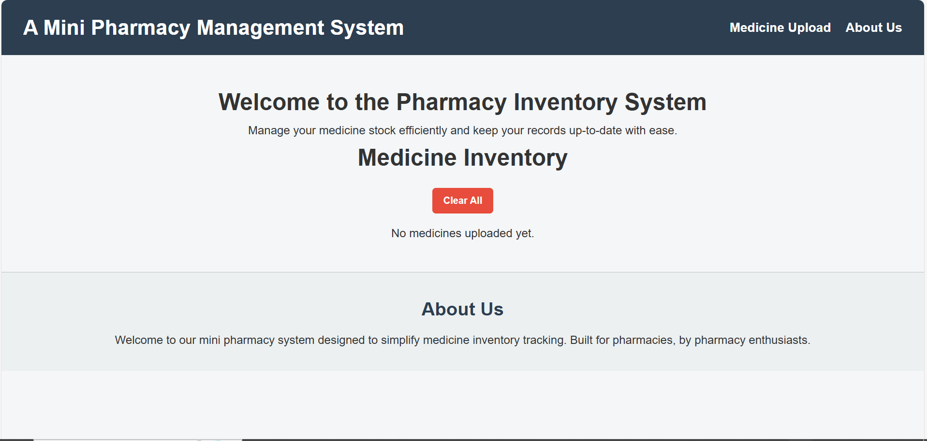

Pharmacy Management System - Homepage

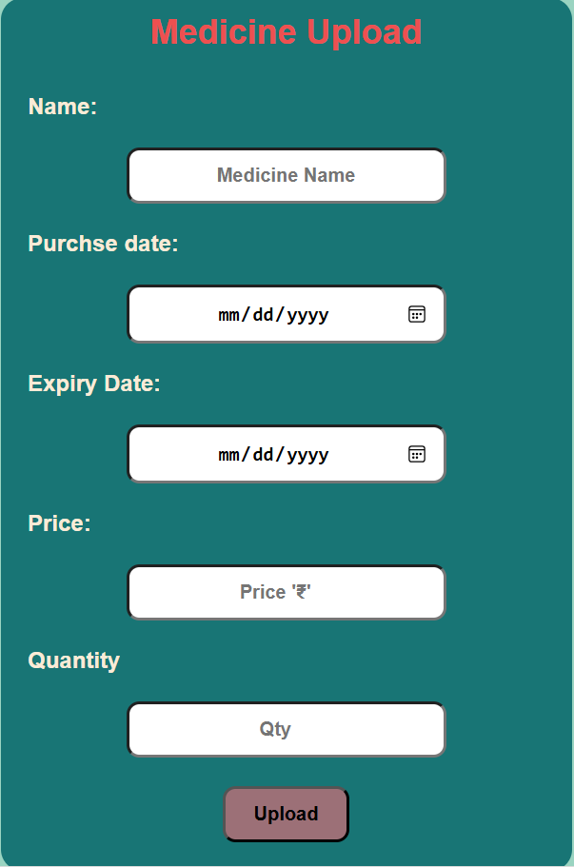

Pharmacy Management System - Homepage

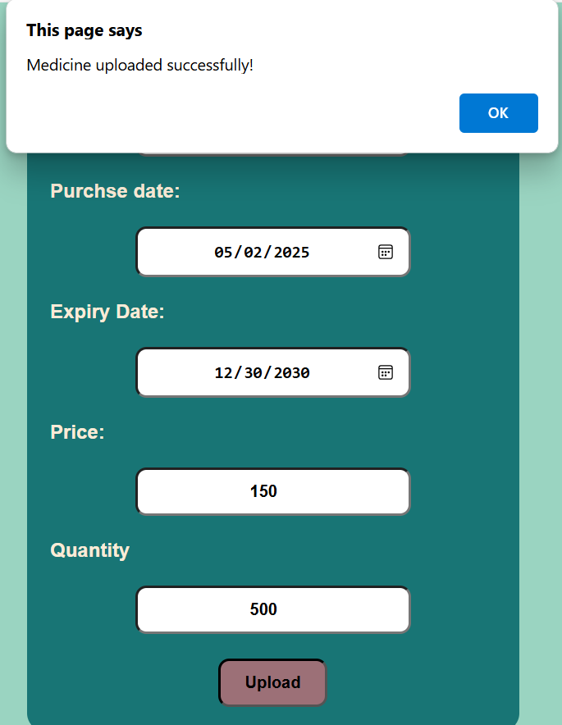

**Medicine Uploaded Confirmation Popup**

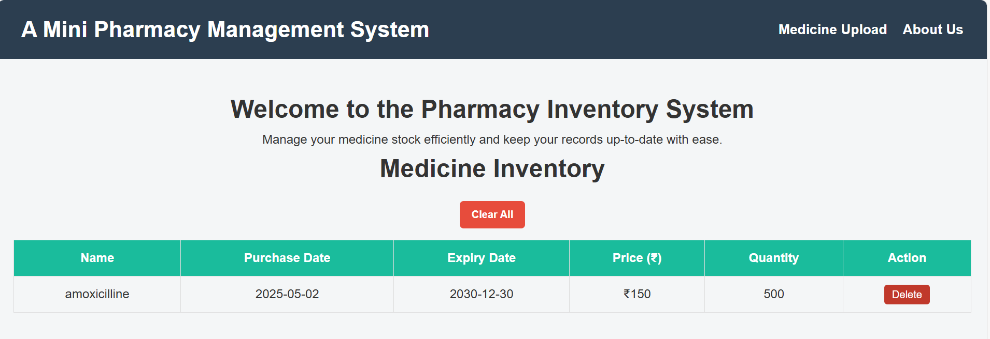

Medicine Inventory List

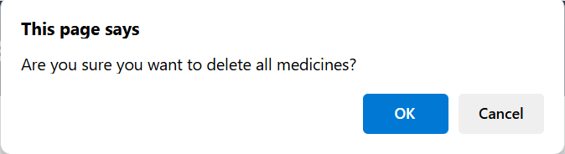

Confirmation for Deleting All Medicines

## 5. CONCLUSION

## The Pharmacy Management Software offers a modern, digital solution to the challenges faced by pharmacies in managing their medicine inventories. By automating manual processes such as inventory tracking, uploading, and updating of medicines, it simplifies the task of managing a pharmacy’s stock.

## The system enhances efficiency and minimizes errors associated with manual data entry, ensuring accurate and up-to-date records of all pharmaceutical products.

## With a user-friendly interface, the software ensures that pharmacy staff can quickly adapt to and benefit from the system, improving productivity and operational efficiency. Features such as the ability to track expiry dates, delete outdated inventory, and securely manage user permissions add layers of functionality that make inventory management seamless and secure.

## The scalability of the system means that it can be easily customized to accommodate the growing needs of both small pharmacies and large pharmacy chains. As the pharmacy industry becomes increasingly digitized, this system provides the necessary tools to keep up with regulatory demands and market changes.

## Future enhancements, such as integration with supplier databases and analytics dashboards, will further empower pharmacy staff to manage their inventory proactively.

## The Pharmacy Management Software transforms pharmacy operations by reducing administrative overhead, improving stock accuracy, and ensuring that customers are always provided with safe, quality medications.

## 6. BIBLIOGRAPHY

1. OpenAI: "GPT-3: Language Models for Text Generation." https://[www.openai.com](http://www.openai.com/)
2. GeeksforGeeks: "Computer Science Portal." [https://www.geeksforgeeks.org](https://www.geeksforgeeks.org/)
3. YouTube: “Various Tutorials and Educational Content." https://[www.youtube.com](http://www.youtube.com/)